**Work Breakdown Structure**

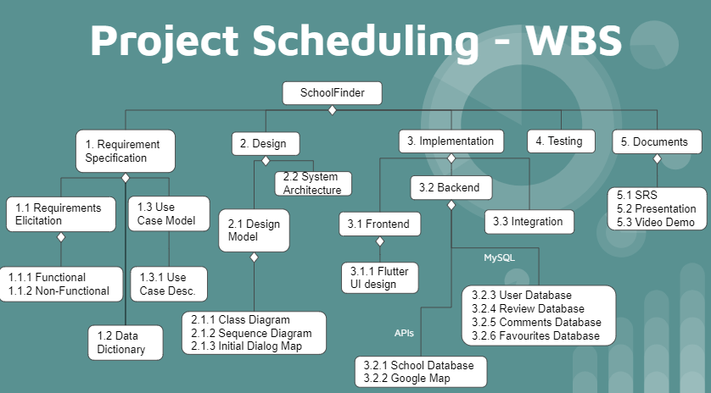

Figure 1: Work Breakdown Structure

We used a Wideband Delphi method to agree upon the Work Breakdown Structure of our project. We divided the work according to our strengths and tried to find the critical path which in this case was the implementation phase. (e.g. Inclusion of the API and creation of databases)

We used this as our critical path and timed all our activities around it. First we listed out all the tasks and thereafter used the wideband delphi method to agree on the time needed for each phase and split the work.

|  |  |
| --- | --- |
| **Week** | **Tasks** |
| 3 | 1.1 & 1.2 |
| 4 | 1.3 & Concurrently pick up Flutter and API fetching (3.1.1 & 3.2) |
| 5 | 2.1 & Concurrently pick up Flutter and API fetching (3.1.1 & 3.2) |
| 6 | 2.2 & 3.2 & Concurrently pick up Flutter UI design (3.1.1) |
| 7 | 3.1 & 3.3 |
| 8 | 3.1 & 3.3 |
| 9 | 3 & 4 & Concurrently work on documentation (5) |
| 10 | 5 |
| 11 | Completed & prepare for presentation |
| 12 | Project submission |

Table 1: Tasks outline